Antenna Report

# Plots

## P1 Cart

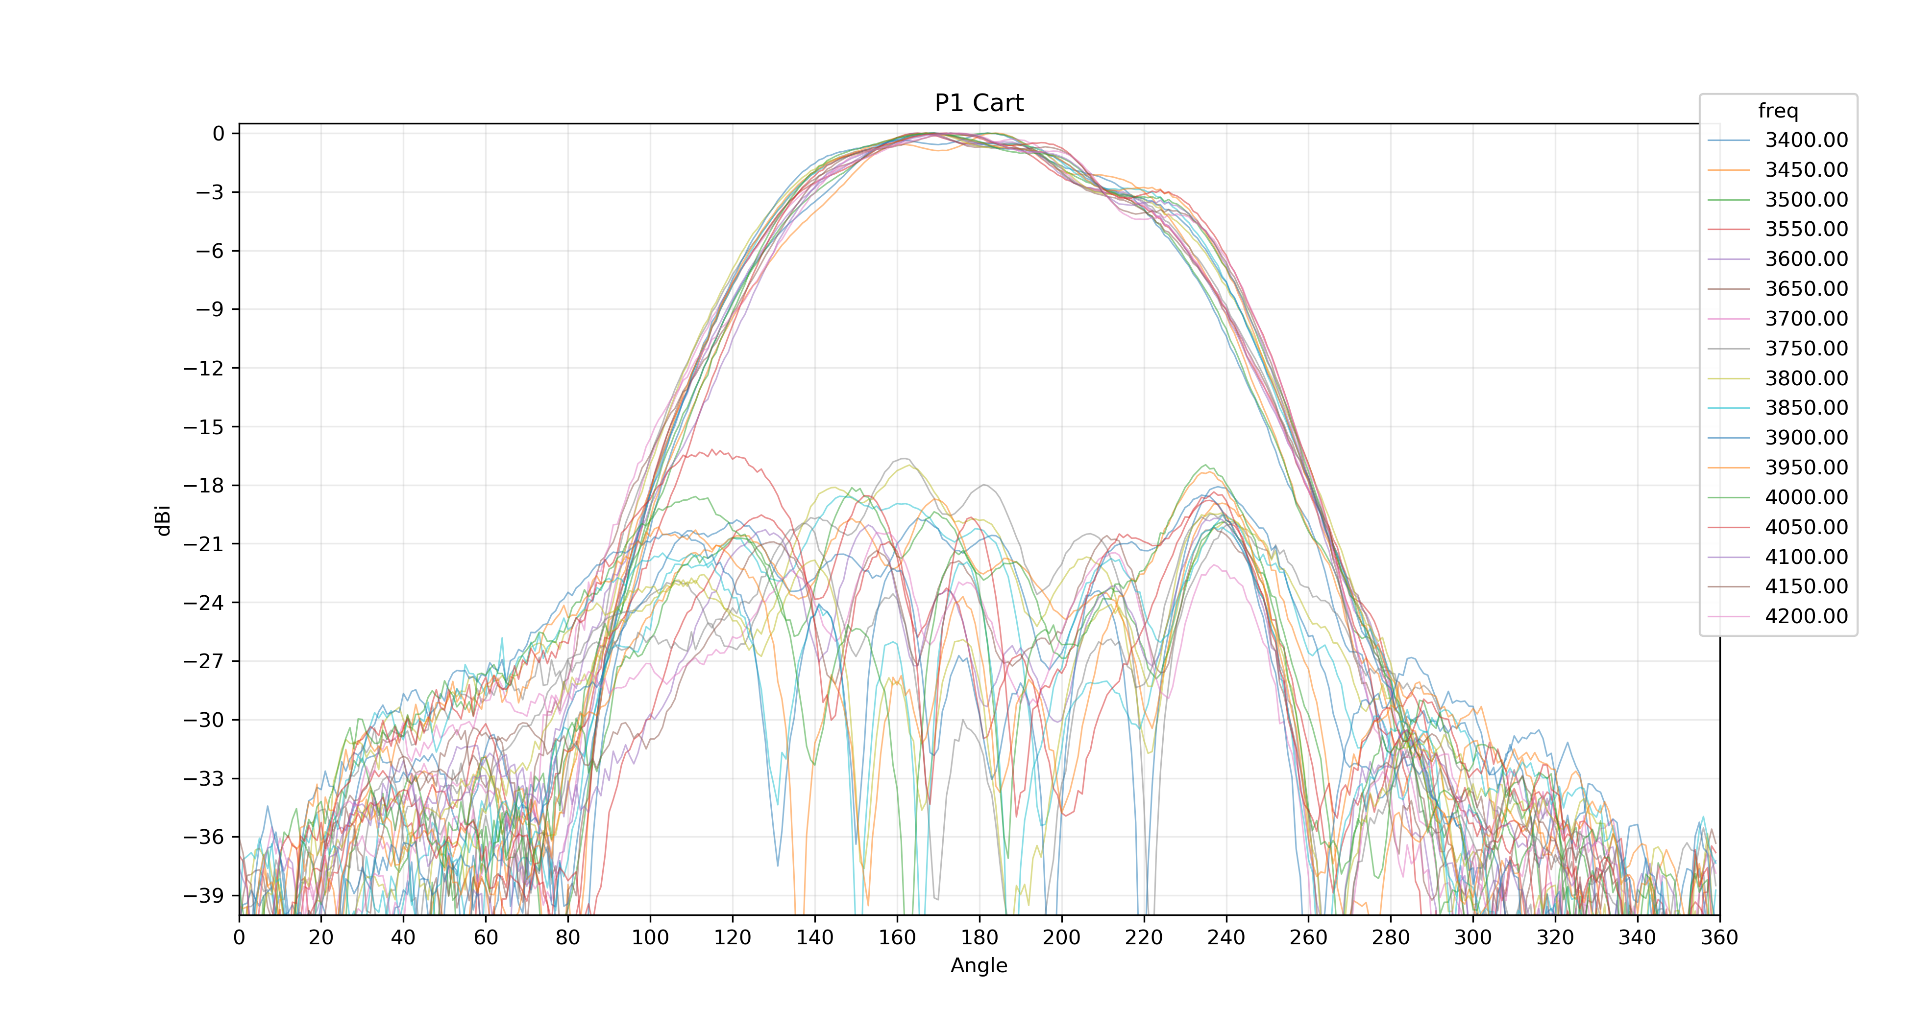

## P1 EL T0 CO Cart

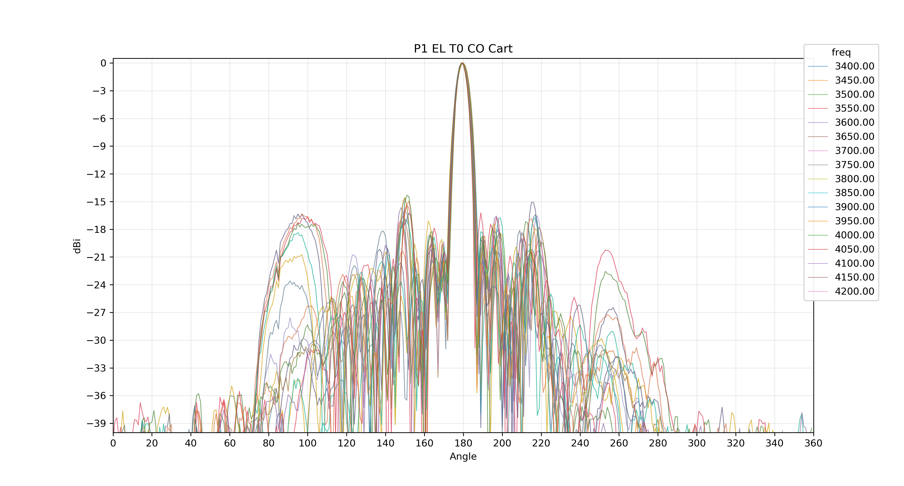

## P2 Cart

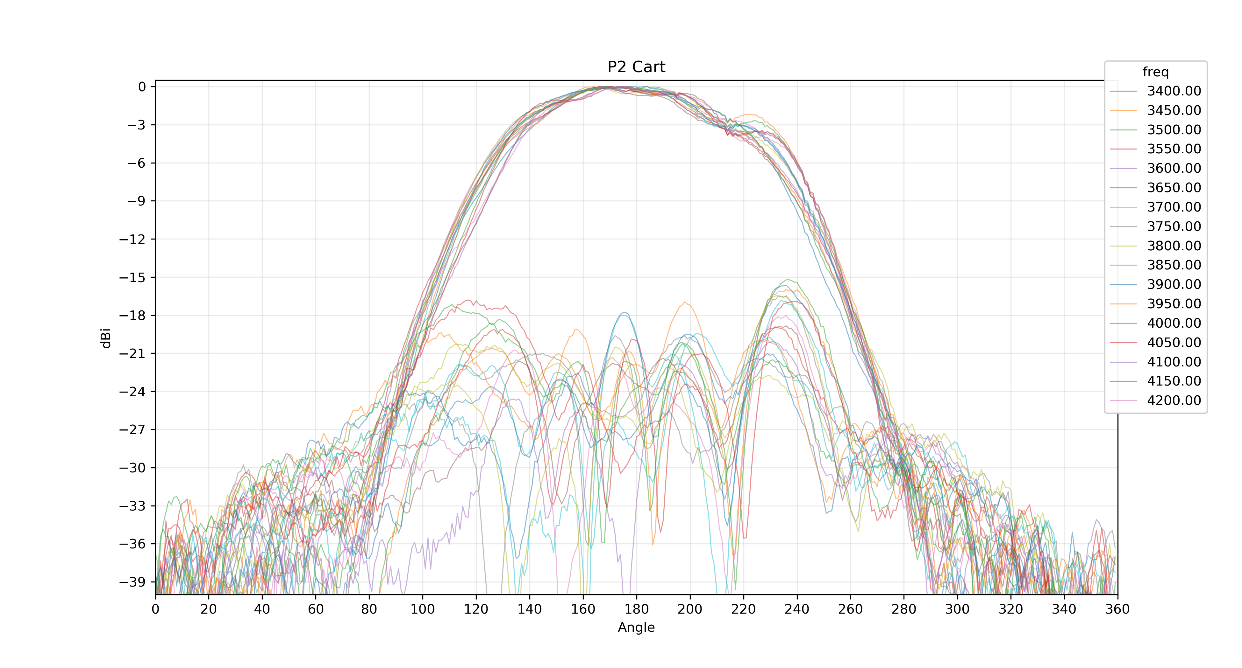

## P2 EL T0 CO Cart

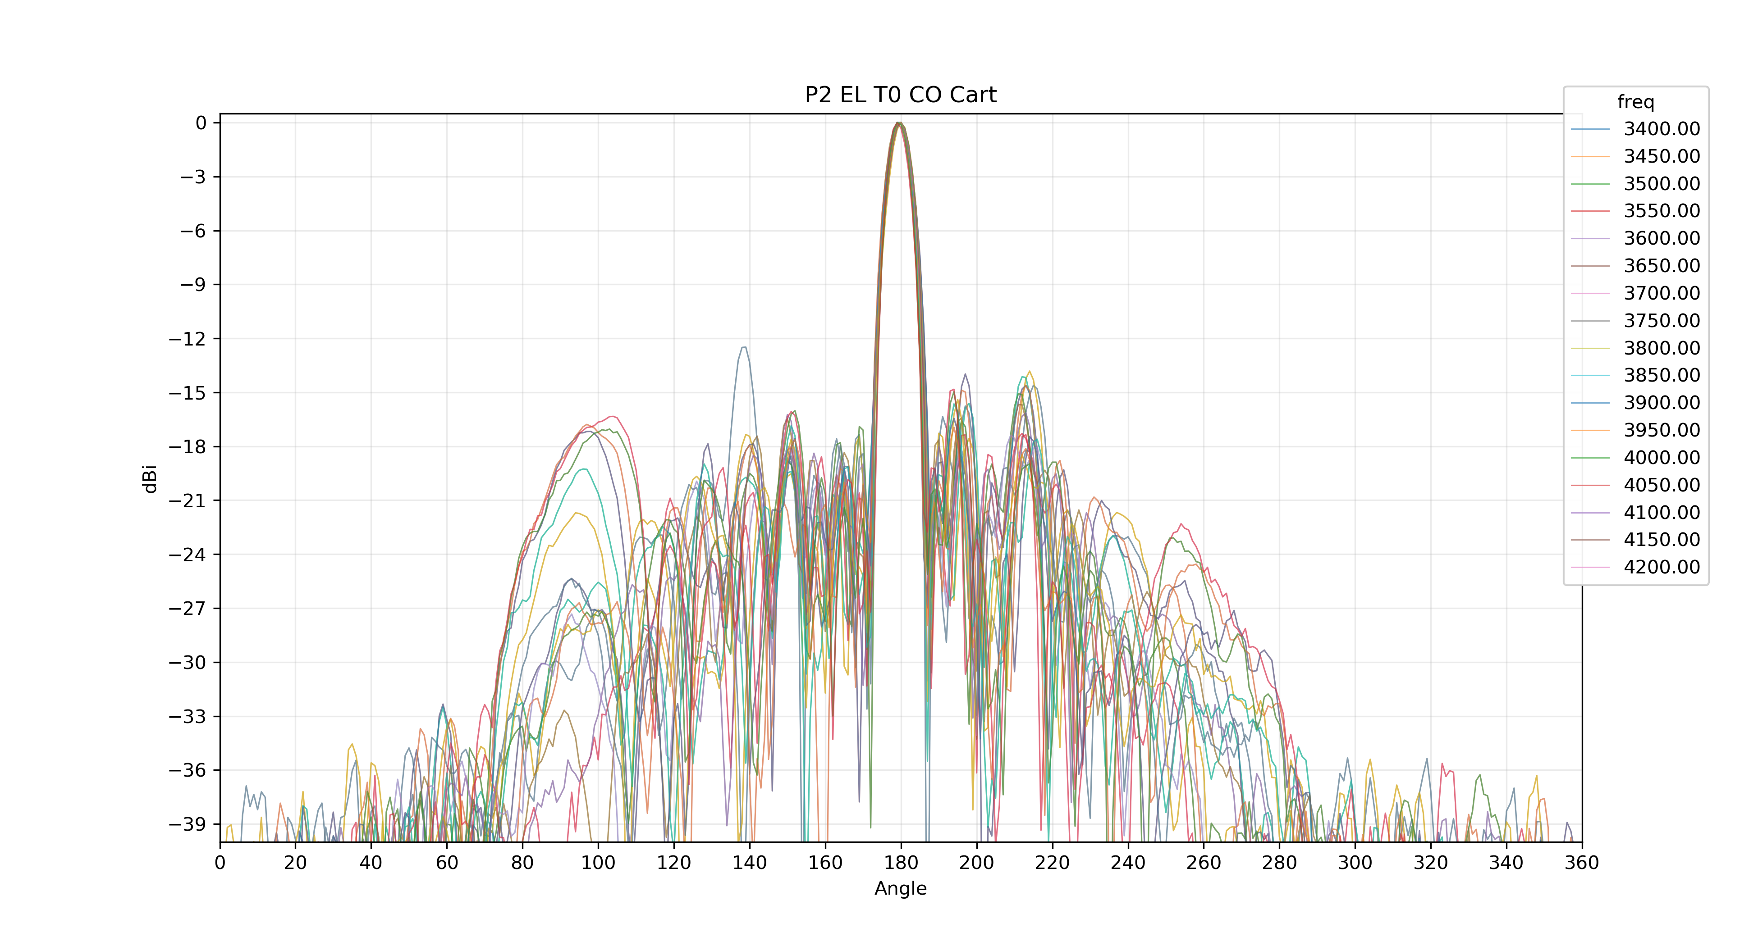

# Radiation Tables

## Az Co 3dB Beamwidth

|  |  |  |  |  |
| --- | --- | --- | --- | --- |
| Item | Spec | Frequency | P1 | P2 |
| Az Co 3dB Beamwidth |  | 3400.0 | 73.01 | 76.47 |
| 3450.0 | 74.86 | 71.39 |
| 3500.0 | 71.73 | 78.83 |
| 3550.0 | 73.49 | 71.57 |
| 3600.0 | 74.91 | 71.48 |
| 3650.0 | 71.11 | 71.58 |
| 3700.0 | 72.31 | 87.57 |
| 3750.0 | 74.06 | 83.0 |
| 3800.0 | 74.48 | 76.65 |
| 3850.0 | 86.15 | 72.22 |
| 3900.0 | 80.52 | 74.98 |
| 3950.0 | 90.23 | 95.18 |
| 4000.0 | 76.37 | 80.72 |
| 4050.0 | 89.8 | 74.94 |
| 4100.0 | 70.92 | 71.97 |
| 4150.0 | 72.01 | 72.96 |
| 4200.0 | 70.07 | 72.19 |

|  |  |
| --- | --- |
| Mean | 76.46 |
| Max | 95.18 |
| Min | 70.07 |
| Pass |  |

## Squint of 3dB Midpoint

|  |  |  |  |  |
| --- | --- | --- | --- | --- |
| Item | Spec | Frequency | P1 | P2 |
| Squint of 3dB Midpoint |  | 3400.0 | 0.64 | 0.13 |
| 3450.0 | 2.61 | 2.56 |
| 3500.0 | 3.8 | 1.52 |
| 3550.0 | 6.79 | 6.0 |
| 3600.0 | 3.71 | 4.11 |
| 3650.0 | 8.31 | 7.33 |
| 3700.0 | 6.38 | 2.25 |
| 3750.0 | 7.82 | 2.49 |
| 3800.0 | 9.34 | 8.44 |
| 3850.0 | 2.25 | 8.01 |
| 3900.0 | 7.08 | 8.51 |
| 3950.0 | 0.56 | 2.28 |
| 4000.0 | 6.41 | 3.44 |
| 4050.0 | 1.1 | 7.05 |
| 4100.0 | 5.57 | 5.14 |
| 4150.0 | 6.13 | 3.77 |
| 4200.0 | 4.79 | 3.16 |

|  |  |
| --- | --- |
| Mean | 4.69 |
| Max | 9.34 |
| Min | 0.13 |
| Pass |  |

## Cross Pole

|  |  |  |  |  |
| --- | --- | --- | --- | --- |
| Item | Spec | Frequency | P1 | P2 |
| Cross Pole |  | 3400.0 | 18.05 | 25.15 |
| 3450.0 | 19.65 | 26.38 |
| 3500.0 | 20.24 | 28.66 |
| 3550.0 | 20.31 | 26.7 |
| 3600.0 | 21.89 | 21.52 |
| 3650.0 | 21.89 | 23.08 |
| 3700.0 | 29.16 | 27.29 |
| 3750.0 | 28.21 | 32.56 |
| 3800.0 | 23.3 | 23.14 |
| 3850.0 | 23.19 | 25.12 |
| 3900.0 | 30.67 | 24.59 |
| 3950.0 | 27.6 | 25.41 |
| 4000.0 | 23.24 | 19.72 |
| 4050.0 | 29.48 | 19.31 |
| 4100.0 | 26.14 | 21.81 |
| 4150.0 | 23.28 | 22.7 |
| 4200.0 | 20.0 | 19.84 |

|  |  |
| --- | --- |
| Mean | 24.1 |
| Max | 32.56 |
| Min | 18.05 |
| Pass |  |

## Front to Back Ratio

|  |  |  |  |  |
| --- | --- | --- | --- | --- |
| Item | Spec | Frequency | P1 | P2 |
| Front to Back Ratio |  | 3400.0 | 32.49 | 36.13 |
| 3450.0 | 34.17 | 35.76 |
| 3500.0 | 34.79 | 32.29 |
| 3550.0 | 33.64 | 31.81 |
| 3600.0 | 34.28 | 33.76 |
| 3650.0 | 34.5 | 35.85 |
| 3700.0 | 35.95 | 34.52 |
| 3750.0 | 35.6 | 36.69 |
| 3800.0 | 38.5 | 36.54 |
| 3850.0 | 41.55 | 34.1 |
| 3900.0 | 40.86 | 35.87 |
| 3950.0 | 40.57 | 38.33 |
| 4000.0 | 39.38 | 38.61 |
| 4050.0 | 35.87 | 38.44 |
| 4100.0 | 37.37 | 39.49 |
| 4150.0 | 37.55 | 37.08 |
| 4200.0 | 36.17 | 38.7 |

|  |  |
| --- | --- |
| Mean | 36.39 |
| Max | 41.55 |
| Min | 31.81 |
| Pass |  |

## 3dB Beamwidth EL T0 CO

|  |  |  |  |  |
| --- | --- | --- | --- | --- |
| Item | Spec | Frequency | P1 | P2 |
| 3dB Beamwidth EL T0 CO |  | 3400.0 | 7.12 | 6.71 |
| 3450.0 | 6.97 | 6.05 |
| 3500.0 | 6.75 | 6.33 |
| 3550.0 | 6.65 | 6.96 |
| 3600.0 | 7.08 | 7.18 |
| 3650.0 | 6.69 | 6.72 |
| 3700.0 | 6.34 | 6.05 |
| 3750.0 | 6.37 | 6.51 |
| 3800.0 | 6.77 | 6.93 |
| 3850.0 | 6.52 | 6.58 |
| 3900.0 | 6.04 | 6.15 |
| 3950.0 | 5.97 | 6.13 |
| 4000.0 | 6.16 | 6.23 |
| 4050.0 | 6.23 | 6.13 |
| 4100.0 | 5.9 | 5.82 |
| 4150.0 | 5.54 | 5.76 |
| 4200.0 | 5.67 | 5.8 |

|  |  |
| --- | --- |
| Mean | 6.38 |
| Max | 7.18 |
| Min | 5.54 |
| Pass |  |

## 1st upper sidelobe EL T0 CO

|  |  |  |  |  |
| --- | --- | --- | --- | --- |
| Item | Spec | Frequency | P1 | P2 |
| 1st upper sidelobe EL T0 CO |  | 3400.0 | 18.62 | 17.36 |
| 3450.0 | 19.11 | 17.48 |
| 3500.0 | 18.75 | 20.69 |
| 3550.0 | 20.26 | 19.11 |
| 3600.0 | 19.71 | 20.87 |
| 3650.0 | 18.22 | 16.89 |
| 3700.0 | 19.73 | 20.67 |
| 3750.0 | 19.49 | 20.57 |
| 3800.0 | 18.93 | 18.39 |
| 3850.0 | 20.6 | 18.87 |
| 3900.0 | 21.44 | 18.4 |
| 3950.0 | 19.7 | 20.58 |
| 4000.0 | 18.89 | 19.15 |
| 4050.0 | 20.04 | 19.31 |
| 4100.0 | 21.7 | 20.1 |
| 4150.0 | 21.17 | 21.47 |
| 4200.0 | 17.91 | 19.85 |

|  |  |
| --- | --- |
| Mean | 19.53 |
| Max | 21.7 |
| Min | 16.89 |
| Pass |  |

## USL in range EL T0 CO

|  |  |  |  |  |
| --- | --- | --- | --- | --- |
| Item | Spec | Frequency | P1 | P2 |
| USL in range EL T0 CO |  | 3400.0 | 18.18 | 12.47 |
| 3450.0 | 17.12 | 17.33 |
| 3500.0 | 18.75 | 19.38 |
| 3550.0 | 20.17 | 17.88 |
| 3600.0 | 18.69 | 17.95 |
| 3650.0 | 17.71 | 16.89 |
| 3700.0 | 17.05 | 18.1 |
| 3750.0 | 15.7 | 16.28 |
| 3800.0 | 16.64 | 16.49 |
| 3850.0 | 15.95 | 18.01 |
| 3900.0 | 14.68 | 18.0 |
| 3950.0 | 14.58 | 17.66 |
| 4000.0 | 16.9 | 16.9 |
| 4050.0 | 16.29 | 17.61 |
| 4100.0 | 14.99 | 17.65 |
| 4150.0 | 14.33 | 16.03 |
| 4200.0 | 15.38 | 16.07 |

|  |  |
| --- | --- |
| Mean | 16.88 |
| Max | 20.17 |
| Min | 12.47 |
| Pass |  |

## USL in range (BS) EL T0 CO

|  |  |  |  |  |
| --- | --- | --- | --- | --- |
| Item | Spec | Frequency | P1 | P2 |
| USL in range (BS) EL T0 CO |  | 3400.0 | 18.18 | 12.47 |
| 3450.0 | 17.12 | 17.33 |
| 3500.0 | 18.75 | 19.38 |
| 3550.0 | 20.17 | 17.88 |
| 3600.0 | 18.69 | 17.95 |
| 3650.0 | 17.71 | 16.89 |
| 3700.0 | 17.05 | 18.1 |
| 3750.0 | 15.7 | 16.28 |
| 3800.0 | 16.64 | 16.49 |
| 3850.0 | 15.95 | 18.01 |
| 3900.0 | 14.68 | 18.0 |
| 3950.0 | 14.58 | 17.66 |
| 4000.0 | 16.9 | 16.9 |
| 4050.0 | 16.29 | 17.61 |
| 4100.0 | 14.99 | 17.65 |
| 4150.0 | 14.33 | 16.03 |
| 4200.0 | 15.38 | 16.07 |

|  |  |
| --- | --- |
| Mean | 16.88 |
| Max | 20.17 |
| Min | 12.47 |
| Pass |  |

## Peak Deviation EL T0 CO

|  |  |  |  |  |
| --- | --- | --- | --- | --- |
| Item | Spec | Frequency | P1 | P2 |
| Peak Deviation EL T0 CO |  | 3400.0 | 0.0 | 0.0 |
| 3450.0 | 0.0 | 0.0 |
| 3500.0 | 0.0 | 0.0 |
| 3550.0 | 1.0 | 1.0 |
| 3600.0 | 0.0 | 0.0 |
| 3650.0 | 0.0 | 0.0 |
| 3700.0 | 0.0 | 0.0 |
| 3750.0 | 1.0 | 0.0 |
| 3800.0 | 0.0 | 1.0 |
| 3850.0 | 0.0 | 0.0 |
| 3900.0 | 0.0 | 0.0 |
| 3950.0 | 1.0 | 0.0 |
| 4000.0 | 1.0 | 1.0 |
| 4050.0 | 1.0 | 0.0 |
| 4100.0 | 1.0 | 0.0 |
| 4150.0 | 1.0 | 1.0 |
| 4200.0 | 1.0 | 1.0 |

|  |  |
| --- | --- |
| Mean | 0.38 |
| Max | 1 |
| Min | 0 |
| Pass |  |

## Tilt Deviation EL T0 CO

|  |  |  |  |  |
| --- | --- | --- | --- | --- |
| Item | Spec | Frequency | P1 | P2 |
| Tilt Deviation EL T0 CO |  | 3400.0 | 0.24 | 0.28 |
| 3450.0 | 0.19 | 0.03 |
| 3500.0 | 0.34 | 0.06 |
| 3550.0 | 0.49 | 0.37 |
| 3600.0 | 0.45 | 0.42 |
| 3650.0 | 0.26 | 0.33 |
| 3700.0 | 0.41 | 0.18 |
| 3750.0 | 0.54 | 0.43 |
| 3800.0 | 0.56 | 0.58 |
| 3850.0 | 0.44 | 0.41 |
| 3900.0 | 0.44 | 0.31 |
| 3950.0 | 0.65 | 0.47 |
| 4000.0 | 0.72 | 0.62 |
| 4050.0 | 0.61 | 0.56 |
| 4100.0 | 0.52 | 0.52 |
| 4150.0 | 0.57 | 0.57 |
| 4200.0 | 0.66 | 0.75 |

|  |  |
| --- | --- |
| Mean | 0.44 |
| Max | 0.75 |
| Min | 0.03 |
| Pass |  |